Lesson 8 Genres of Procedure and Procedural Recount
I. A procedure is not a procedural recount
1. Martine's Genre Relations (P169, 185& 186 of paper version)
Procedure directs us how to act. Procedures are a central feature of many contexts: domestic, recreational, educational, scientific and industrial. We will illustrate a few of these variations here, but our particular concern is with procedures and procedural recounts used in the workplace, and their relationships to education. This focus emerges from a major research project on literacy in science and science based industries, which mapped relations between writing at each level of industry, from the factory floor to research laboratories, with writing at each stage of the science educational sequence, from primary school to doctoral research (Rose 1997, 1998, Rose et al 1992, Veel 1997, 1998). After grounding the discussion in some procedures of the household, recreation and school, including Indigenous Australian contexts, we will trace this industrial hierarchy, from simple to increasingly more complex operating procedures in industry, and then to the procedural recounts that technicians and scientists use to effect changes in scientific knowledge and its applications.
Procedural recounts: Above the level of laboratory technicians, step-by-step procedures are relatively uncommon. These are the levels of ‘professional’ training, qualifications are diplomas to degrees, and workers no longer require detailed procedures to do their jobs. Instead they investigate technical problems, using their knowledge of the technical field and appropriate activities, and report on their investigations in the form of technical notes and research articles. Since both technical notes and research articles recount an investigative procedure, these are forms of procedural recount in the context of school science.

Example:
The relationship between procedure and recount is made explicit in the geography textbook Australian Journey: first the procedure [5:12].
[5:12] Investigating an arid lands mystery Geographers are interested in land management issues that affect arid lands… To do this the geographer follows a number of steps:
Step 1 Identify the issue to be studied.
Step 2 Research the background to the issue.
Step 3 Go on the field trip. While on the field trip it is important to: observe and collect information.
Step 4 Use the observations to identify what is happening.
Step 5 Develop a plan to manage the environment.

This procedure is followed by a recount of field research by biologist Lynn Baker, written in terms accessible and appealing to junior secondary students. This is summarized as [5:13].
[5:13] The mulgara at Uluru National Park
Step 1 Identify the issue to be studied.
Before leaving on the field trip to Uluru National Park, Lynn identified the issue she wished to study and spent time researching it. 'I want to find out why mulgara appear to be in some areas and not in others. If I find that the mulgara are rare I want to be able to suggest ways to conserve their habitat.'

Step 2 Research the background to the issue
Lynn didn't just pack her bags and leave for Uluru. She spent time in the library reading what others have found out about arid zone animals. …

Step 3 The field trip …
The work involved in step 3 can be divided into two parts:
1. Making observations
2. Collecting and recording information
Observing the mulgara and its environment
During her first field trips to Uluru, Lynn spent time observing mulgara and the environments where it lives. …
Collecting and recording information
Now Lynn needed to collect information that would help her find out why the mulgara seemed to be found in different habitats during times of high rainfall and during times of drought. Her first task was to collect data that showed where mulgara were living and where they were not living. …
Using computer mapping to locate relict drainage environments
Earlier you learnt that old river systems can't be seen when walking over the ground. However, photographs taken by satellites, circling thousands of kilometres above the earth, do reveal these old rivers. …

Step 4 Use the observations to identify what is happening
Lynn's next step was to carefully study her observations to see what they told her… She started to develop a theory: 'The theory is that in the relict drainage area the vegetation remains in better condition than in areas outside its influence. This area is better able to support animals during drought. It becomes an important refuge area for animals like the mulgara during times of drought. The mulgara in this area are better able to survive than those living elsewhere. This is because the plants are able to collect the water from the underground drainage system. When it rains the habitat in the rest of the country improves. The mulgara are able to spread out over the country and I will find mulgara living away from this area again.' …

Step 5 Develop a plan to manage the environment
Geographers conduct field work to help them decide on ways to manage the environment. When Lynn Baker's work is complete she wants to be able to suggest things that can be done to protect and save the mulgara. This means protecting the environments where it lives.
At this stage Lynn believes the refuge areas that are found in our arid lands must be protected, as the research so far suggests that small animals like the mulgara do rely on them in droughts. …
Scott & Robinson 1993:54-58
2. More detailed information on the differences between a procedure and a procedural recount can be found on the page of 88, 89 &90 of the paper version of Science Research Writing (or on the page of 48&49 of the PDF version of the same book) (the materials can't be copied here from the PDF file and the instructors can show the students the materials of its PDF form.)
II. How to write a procedure: A procedure is a set of very specific instructions about
how you are going to conduct your experiment(or other specialized activities).
1. One example: Consider the image below. What happened to the sandwich on the
left?
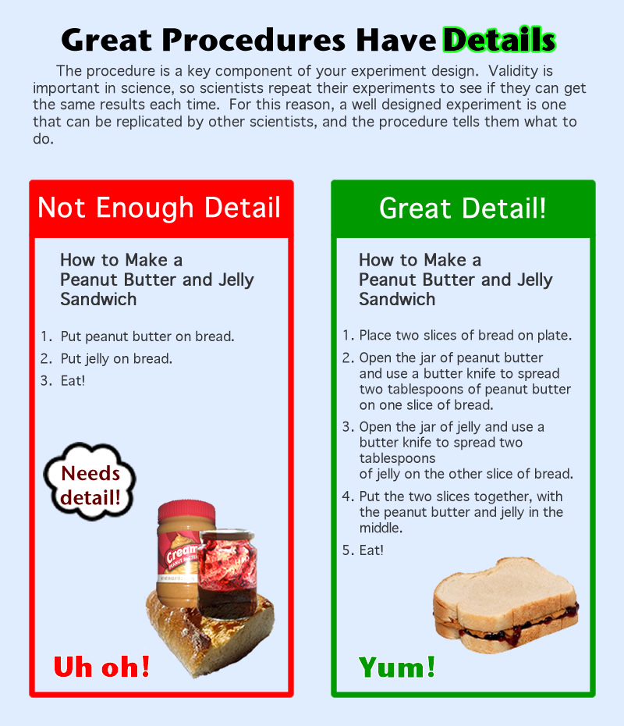
The problem of the procedure on the left is a lack of details. Details are the most important part of any experiment because without details, it would be nearly impossible for someone else to replicate your experiment.
2. Variables: Details also help to control variables in your experiment. Before you can begin writing the procedure, you need to decide on your independent variable. There are three types of variables to consider:
Independent Variable: The independent variable is the one that YOU choose to help you answer your question. A well designed experiment has only one independent variable. That means you can only change one condition in each experiment. This type of variable is something that you do differently in each trial (i.e. the type of liquid you give each plant changes, the weight of the ball you throw is different each time). Nothing else should change but this one variable.
Controlled Variables: These are all the materials, measurements, and methods that you want to stay exactly the same so that the only thing responsible for change is the independent variable you chose. Every experiment has many controlled variables. These variables should be exactly the same for every trial (i.e. the type of plant used should be exactly the same; the target for the ball is always the same distance away).
Dependent Variable: The dependent variable is the thing that changes as a result of your independent variable, or the one thing that you intentionally changed. This is like cause and effect. What happened (the dependent variable) because of what you changed (independent variable)?
If there's more than one independent variable, the experiment becomes flawed because you can't be sure what caused the changes you observed. It can be hard to figure out what other conditions must stay the same, but it is important to think it through before you start your experiment.
3. Activity #1: Look at the image to the right. Suppose this is Paul's experiment, asking which liquid will help plants grow tallest. The student hypothesized that the plant given soda will grow tallest because plants need CO₂, and soda has plenty of that! There are many things this student needs to consider so that the liquid type is the only thing that can affect the growth of the plant.
Take some time to think about how this student might write the procedure for this experiment:
- What are the controlled variables?
- What details can the student include to make sure these variables are controlled throughout the experiment?
- What is the dependent variable?
- How can the student measure change?
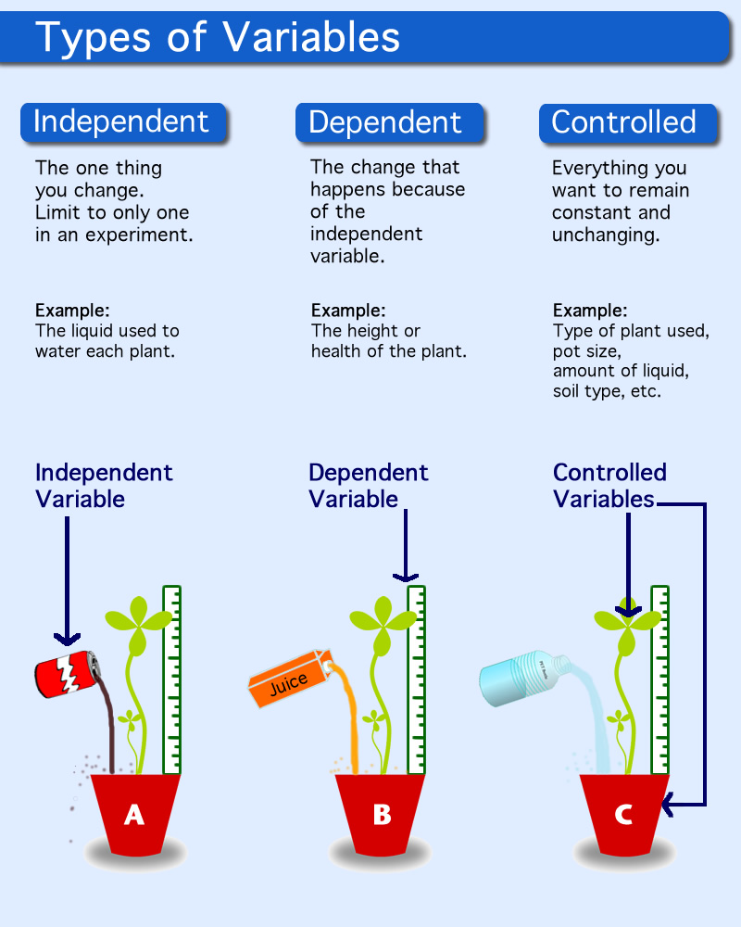
- What might this student's procedure look like?

Tips:
Tip #1: Think about how long your experiment will take before you decide on your procedure. If you only have a few weeks to do your experiment, don't write a procedure that will take months to carry out.
Tip #2: Think about your "sample size". How many seedlings will you test with each liquid? A good rule is to repeat your experiment three times, so allow a big enough sample so you can have a few duds in each group, just in case something goes wrong.
Tip #3: Make a list of all of your variables. Make sure you include very specific details to ensure your controlled variables are truly controlled (the same in all trials).
Tip #4: Once you decide on a procedure, write it down step by step. That way, you can prove what you did and can follow the same procedure if you, or someone else, needs to repeat the experiment. Don't forget to include the exact materials you need (i.e. what kind of plant, pot size, etc.), how you'll measure your dependent variable (i.e. the amount plant growth in centimeters), and a chart, journal or other methods of recording results and observations.
Activity #2: Adding Details
Below is a procedure for making lemonade. It's pretty obvious, even to a beginner, that this procedure needs help!
Rewrite the procedure for lemonade so that it is fantastically detailed. Could they follow your procedure? Was anything missing?
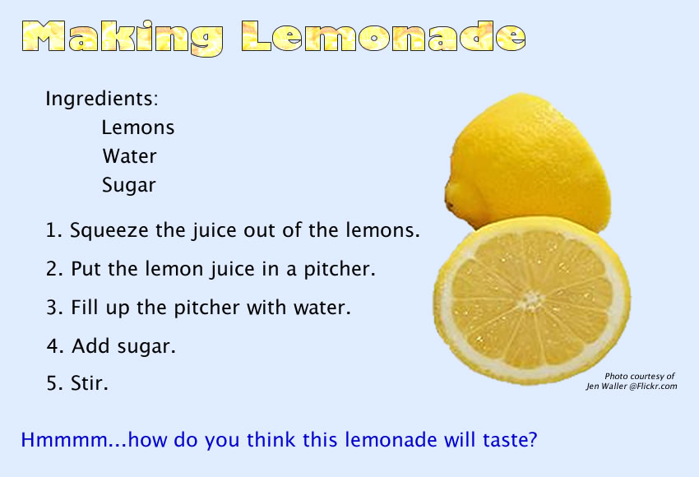
Now that you've learned all about writing the procedure, variables, and the importance of details, it’s time to start writing your own procedure. Take some time to consider your own experiment design. What is your independent variable? What will you be sure to control and keep constant? What materials do you need? Start writing each step in your procedure, including as many details as you can. When you have a rough draft completed, share it with your teacher and see if they can follow it. Ask them to look for missing details. Revise your procedure based on your teacher's feedback.
Assignment
Choose one of your favorite dishes and write a recipe of it.

